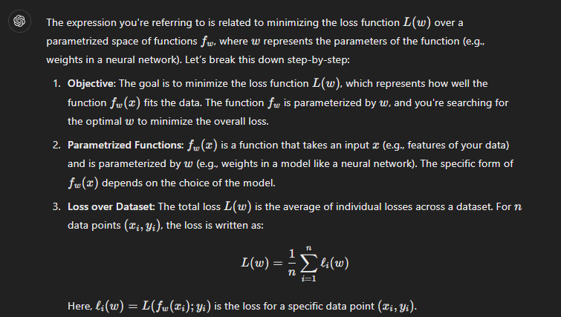

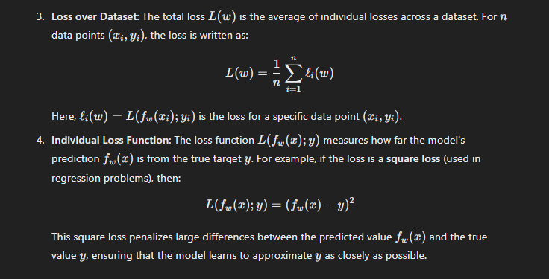

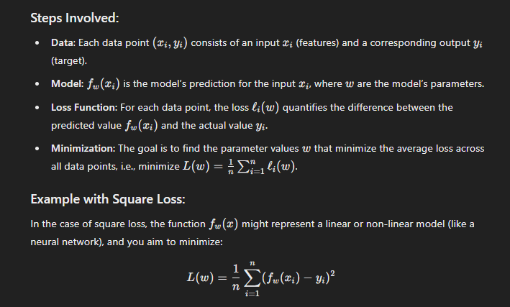

The optimization process (often done using techniques like gradient descent) adjusts the parameters www to minimize this squared error.

In summary, this expression represents an optimization problem where you are trying to minimize the average loss over a dataset by adjusting the parameters www of your model fwf_wfw​.